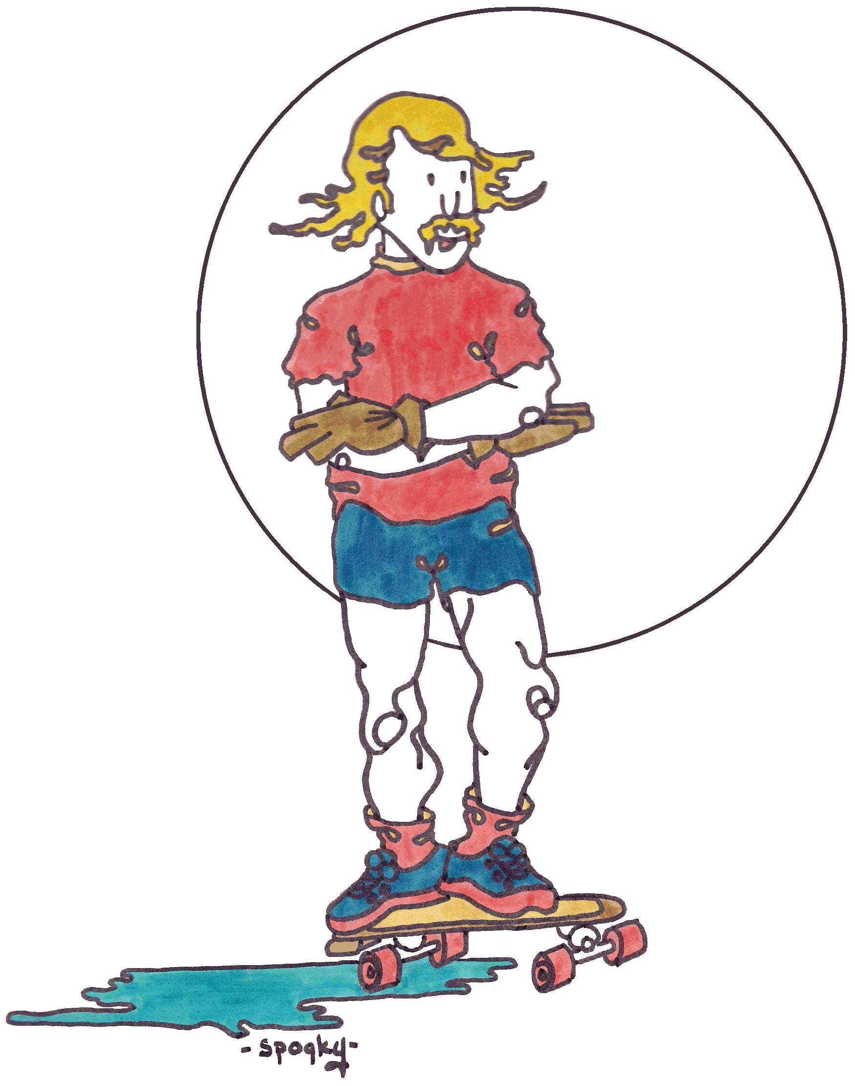
I don’t suffer from dizziness,
I enjoy Spinning through Life
Every chance I get!

I don’t suffer from dizziness,
I enjoy Spinning through Life
Every chance I get!

