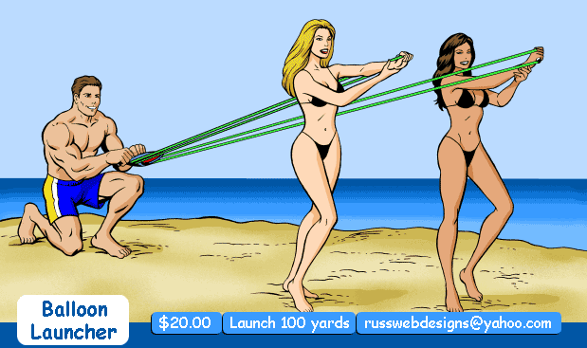

Water-Balloon Launcher Instructions:
SAFETY:
- Never launch anything that you would not want to get hit with yourself. It will hit you someday!
- Never launch against anybody that does not want to get hit. People get angry!

LAUNCHING:
- Grab both handles by gripping hands around the entire handle. Don’t place thumbs between plastic handle and rubber loop. Your grip holds the handle assembly together when rubber cords are stretched.
- Place foot strap under foot and 3” back from toe. Smooth shoes release better.
- The foot that controls the launcher foot strap should be kept behind with the empty foot out in front of you. This will point the projectile away from you.
- When releasing the foot strap, be sure to keep your heel on the ground and lift only your toes. If your heel comes off the ground, your foot will swing out in front and release the projectile into your face.

3-PERSON LAUNCHING:
- Have two people hold the handles as high as possible. Handles should not be further than two feet apart.
The water balloon will often not release or will break if the distance between the handles is too far.
- The third person holds the water balloon in the pocket and pulls it back at a 45 degree angle.

TIPS:
- Water balloons filled to the size of a tennis ball work best.
- Large or heavy objects don’t go as far.
- Don’t twist the rubber cords when launching.
- Keep the nylon pocket stretched along the rubber cords.
- Launching with the cords at a 45 degree angle will give the best distance.

Filename: WaterBalloonLauncher-Instructions.doc

Water-Balloon Launcher Parts List

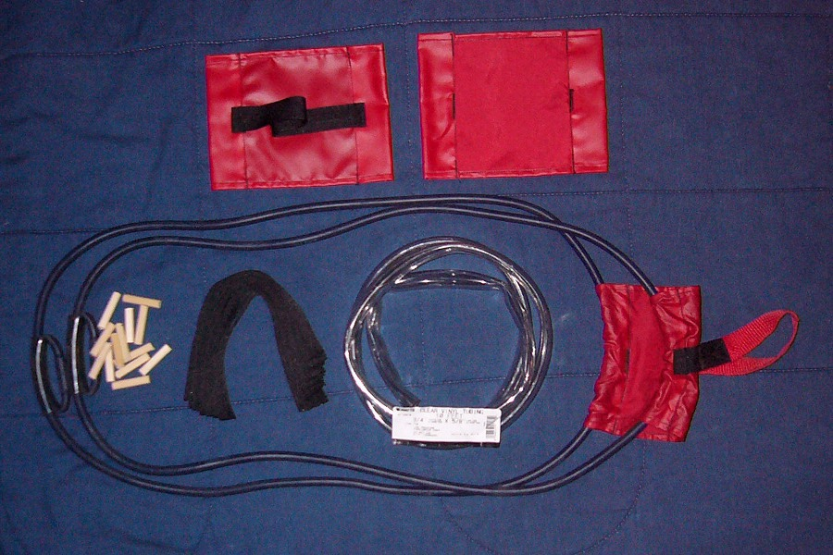

CONSTRUCTION MATERIALS:
Latex Tubing: Inner Diameter = 1 / 4”, Wall Thickness = 3 / 32”, Length = 52” (Each Strap)
Available at:
Kent Latex Products
Kent, Ohio 44240
Division of Meridian Industries, Inc.
Nylon Pocket: Resinated Nylon (RipStock Nylon sticks to the balloons when it gets wet)
Finished Size: Length = 7”, Width = 5 1 / 4”
Tube Sleeve Width = 1 3 / 8”
Nylon Foot Strap: Length = 10”, Width = 1”
Clear Vinyl Tubing (Plumbing Dept): Outside Diameter = 3 / 4”, Inner Diameter = 5 / 8”, Length = 3”
Wooden Dowel Plug for joining Latex Tubing together: Diameter = 5 / 16”, Length = 1 / 2”

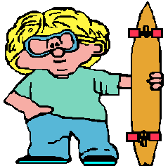
CONTACT:
Russ Howell
3559 Centennial Way
Boise, Idaho 83706 USA
E-mail: russwebdesigns@yahoo.com
Website: http://www.skatewhat.com/russhowell/index.html

